Experiment 2

Aim
To execute and understand the usage of less, more and vi commands.

Procedure
1. Create a text file.
2. Open the file using less.
3. Open the file using more.
4. Edit the file using vi.

Output
- less command
Displays file contents page by page.
less filename.txt

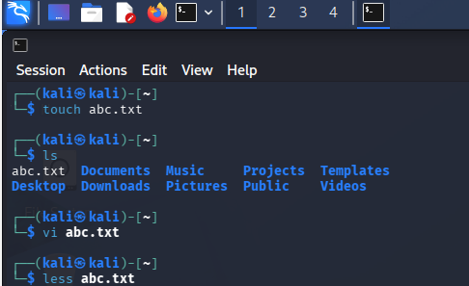
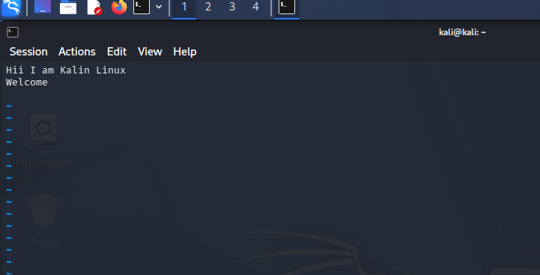
- more command
Displays file contents one screen at a time.
more filename.txt

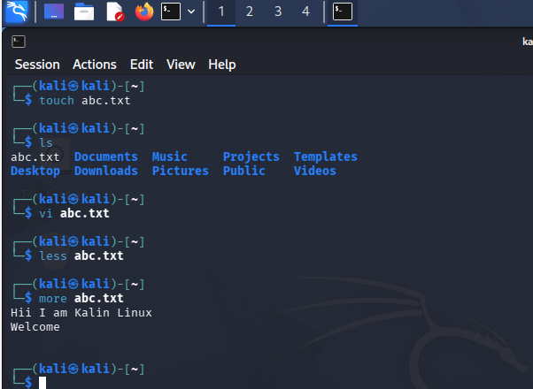

- vi command
Text editor used to create and edit files.
vi filename.txt

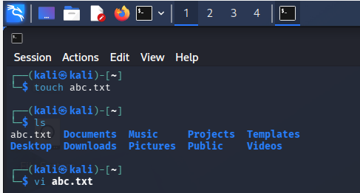

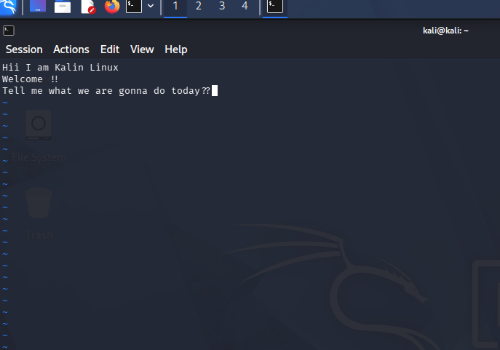
Result
Successfully executed file viewing and editing commands

